https://www.fda.gov/AboutFDA/WhatWeDo/History/Overviews/ucm056044.htm

The Story of the Laws Behind the Labels
Wallace F. Janssen, FDA Historian
(from FDA Consumer, June 1981)
Part I: The 1906 Food and Drugs Act
The history of the Food and Drug Administration is also the history of consumer protection as applied to food, drugs, cosmetics, and other products now regulated by the Agency. That history began long before the initials "F," "D," and "A" became household words, as this article points out. Wallace F. Janssen began writing about FDA as a trade journal editor in 1931. He joined the Agency in 1951 as assistant to the commissioner for public information and continued to be its information chief until 1966.

Troubling Marketplace
Conditions in the U.S. food and drug industries a century ago can hardly be imagined today. Use of chemical preservatives and toxic colors was virtually uncontrolled. Changes from an agricultural to an industrial economy had made it necessary to provide the rapidly increasing city population with food from distant areas. But sanitation was primitive in the light of modern standards. Ice was still the principal means of refrigeration. The great pioneers of bacteriology were just starting their string of victories over infectious diseases. Milk was still unpasteurized. Cows were not tested for tuberculosis.
In the same era, thousands of so called "patent" medicines such as "Kick-a-poo Indian Sagwa" and "Warner's Safe Cure for Diabetes" reflected both the limited medical capability of the period and public acceptance of the doctrine that the buyer could and should look out for himself. Medicines containing such drugs as opium, morphine, heroin, and cocaine were sold without restriction. Labeling gave no hint of their presence. Otherwise harmless preparations were labeled for the cure of every disease and symptom. Labels did not list ingredients and warnings against misuse were unheard of. What information the public received came frequently from bitter experience.
The medicine men competed with the circuses, the minstrel shows, and "wild west" performers to entertain the public -- and sell their products. Hamlin's Wizard Oil (Figure 7) had one of the most popular and spectacular of the big touring medicine shows. For minor aches and pains, this liniment continued to be sold for many years after the shows had ceased. A center spread in Collier’s Weekly for December 1, 1905 (Figure 8), told a pathetic story of the harm done by narcotic "tonics" sold to trusting women. Labels, generally, said nothing about the ingredients in the patent cure-alls.
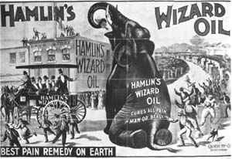 | 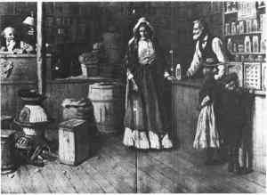
Figure 7 | Figure 8
Wiley and the Crusade for a Law
While such practices were by no means universal, and many firms were producing reliable and wholesome products, Dr. Wiley's chemists had no difficulty getting material for their investigations and reports. Wiley took their findings to the public, becoming a popular speaker at women's clubs, civic and business organizations. Crusading writers joined in the campaign. National magazines, such as Collier’s Weekly, the Ladies Home Journal, and Good Housekeeping, aroused public opinion with their cartoons, articles, and editorials.
Three of Dr. Wiley's most effective supporters: Mrs. Walter McNab Miller, president of the General Federation of Women's Clubs; Dr. Edward F. Ladd, of North Dakota, a leader among the state food and drug officials; and Miss Alice Lakey, of the National Consumers League (shown in Figure 9, left to right respectively). Historians and Dr. Wiley himself credit the club women of the country for turning the tide of public opinion in favor of the "pure food" bill.
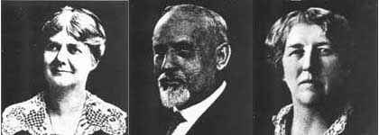
Figure 9

In 1902, Wiley captured the attention of the country by establishing a volunteer "poison squad" of young men who agreed to eat only foods treated with measured amounts of chemical preservatives, with the object of demonstrating whether these ingredients were injurious to health (see Figure 10). Overnight the press made the "Poison Squad" a national sensation. Even the minstrel shows had songs about the squad -- officially designated the "Hygienic Table."
"O, they may get over it but they'll never look the same,
That kind of bill of fare would drive most men insane.
Next week he'll give them mothballs, a la Newburgh or else plain;
O, they may get over it but they'll never look the same."
(Chorus from "Song of the Poison Squad,"
Lew Dockstader's Minstrels, October 1903)

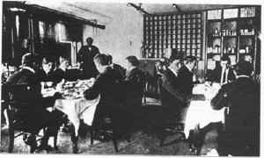
Figure 10
Chemicals fed to the young men included borax; salicylic, sulphurous, and benzoic acids; and formaldehyde. The experiments went on for 5 years. Wiley and the public became convinced that chemical preservatives should be used in food only when necessary; that the burden of proving safety should fall on the producer; and that none should be used without informing the consumer on the label -- basic principles of today's law and regulations. William R. Carter (Figure 11), was one of the earliest African-Americans in the history of FDA. He was hired in 1902 as a cook and waiter for the Poison Squad, earned a degree in pharmaceutical chemistry and served 43 years in the FDA laboratories.
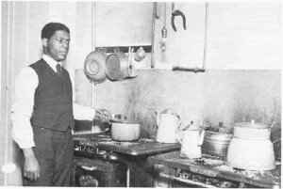Figure 11

Strenuous opposition to Wiley's campaign for a federal food and drug law came from whiskey distillers and the patent medicine firms, who were then the largest advertisers in the country. Many of these men thought they would be put out of business by federal regulation. In any case, it was argued, the federal government had no business policing what people ate, drank, or used for medicine. On the other side were strong agricultural organizations, many food packers, state food and drug officials, and the health professions. But the tide was turned, according to historians and Dr. Wiley himself, when the activist club women of the country rallied to the pure food cause.
Final action followed a sensational portrayal of insanitary conditions in the Chicago meat-packing industry. A single chapter in Upton Sinclair's novel, The Jungle, precipitated legislation expanding federal meat regulation to provide continuous inspection of all red meats for interstate distribution, a far more rigorous type of control than that provided by the pure food bill. Both measures became law the same day, June 30, 1906. J. F. McPhee's 1906 cartoon (Figure 12) reflected the public's expectations concerning the "Wiley Act." The new law, it was hoped, would put a stop to food adulteration and quack remedies -- the two major evils and targets of a 20-year crusade for federal regulation of foods and drugs.

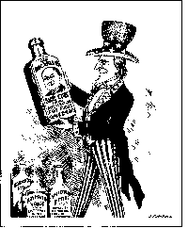
Figure 12 (from the Wiley Papers, Library of Congress)

Enforcing the Wiley Act
Administration of the new law was assigned to the Bureau of Chemistry. The young men and women recruited by Wiley and his successors quickly developed an efficient organization. They continued the development of scientific methods of analysis -- the foundation of food and drug protection. They worked out the legal procedures and the techniques of inspection, and applied them in hundreds of hard-fought court cases. And they won scores of judicial decisions which strengthened the law and also uncovered its weaknesses. Many found such satisfaction that they made FDA their life work.
In 1907 Walter G. Campbell (Figure 13, pictured on the left, listening to Wiley) was one of the first 28 food and drug inspectors (over 2,000 took the civil service examination). Selected by Dr. Wiley as chief inspector, he devised the legal process for the first seizure of a violative product (still used), wrote the first Inspector's Manual (1908), and set up FDA's first project system to ensure uniform enforcement while giving top priority to health hazards. Campbell remained in charge of enforcement for 37 years, becoming the first "Commissioner of Food and Drugs" in 1940. A lawyer by training, Campbell was the leading architect of the present Federal Food, Drug, and Cosmetic Act, passed in 1938. He differed sharply from Wiley in his belief that court proceedings were not the only proper way to secure compliance.

