Name:_____________________________ Date:__________________Period:______
Webquest: http://questgarden.com/189/00/9/170808215541/
LINK 1: “History of Precolonial North America”
Read the section entitled “Impact of Colonialism” and answer the following:
What is the main idea of this section?

Now move onto the section entitled “Main article: Culture Areas” and answer the following:
After reading this section, pick 7 of the following topics to paraphrase into one sentence each. Please use the “power verbs” from the list provided.
Arctic: | Northwest Coast:
Sub-Arctic: | Southwest:
Great Basin: | Plains:
Plateau: | Northeast Woodlands:
California: | Southeast Woodlands:

What is the overall main idea of this section?

LINK 2: “Exploration and Colonization of America”
Read the section entitled “European Exploration of America” and answer the following:
Click on the Explorers in the Interactive Map and read the description of each. After reading, paraphrase in one sentence the evidence presented in this Interactive Map.
Summary:

Read the section entitled “The Colonization of North America” and answer the following:
Write a one sentence paraphrase for each “chunk” of this section. Don’t forget to continue to use the “power verbs” for each sentence.
1st Paragraph:

Interactive Map (hint: the verb “depicts” could work really well in this sentence):

English Settlements:

Spanish Settlements:

Overall main idea of this section:

LINK 3: “Columbus Controversy”
Read the entire article and answer the following:
Write an objective summary of this text starting with the main idea. Don’t forget to use power verbs and transitions throughout your summary. For an adequate summary, write about a sentence per paragraph in this text.
__________________________________________________________________________________________________
__________________________________________________________________________________________________
__________________________________________________________________________________________________
__________________________________________________________________________________________________
__________________________________________________________________________________________________
__________________________________________________________________________________________________
__________________________________________________________________________________________________
__________________________________________________________________________________________________
__________________________________________________________________________________________________
__________________________________________________________________________________________________
__________________________________________________________________________________________________
__________________________________________________________________________________________________
__________________________________________________________________________________________________
__________________________________________________________________________________________________
__________________________________________________________________________________________________
__________________________________________________________________________________________________
__________________________________________________________________________________________________
__________________________________________________________________________________________________
__________________________________________________________________________________________________
__________________________________________________________________________________________________
__________________________________________________________________________________________________
__________________________________________________________________________________________________
__________________________________________________________________________________________________
__________________________________________________________________________________________________
__________________________________________________________________________________________________
__________________________________________________________________________________________________
__________________________________________________________________________________________________
__________________________________________________________________________________________________
__________________________________________________________________________________________________
__________________________________________________________________________________________________
__________________________________________________________________________________________________
__________________________________________________________________________________________________
LINK 4: “History of the United States: Colonial Period”
Read the entire text and answer the following:
What is the main idea of this text?:

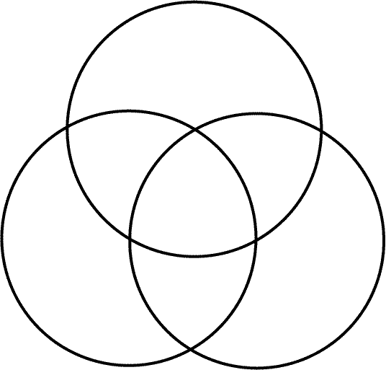
Fill out the chart below highlighting the differences and similarities between the New England, Middle, and Southern colonies.
New England

Southern Colonies
Middle Colonies

