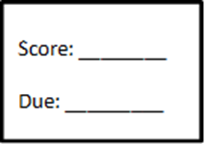
Name Per

Opportunity 1

Part 1 – Pick a topic and explain why it interests you and what you already know about it

- Monopolies
- Environment
- Worker’s Rights/Working Conditions
- Immigration
- Political Corruption
- Lack of consumer protections
- Topic of your choice with teacher approval

____________________________________________________________________________________________________________________________________________________________________________________________________________________________________________________________________________________________________________________________________________________________________________________________________________________________________________________________________________________________________________________________________________________________________________________________________________
________________________________________________________________________________________________________________________________________________________________________________________________________________________________________________________________________________________________________________________________________________________________________________________________________________________________________________________________________________________________________________________________________________________________________________________________________________________________________________________________________________________________________________________________________________________________________________________________________________

Part 2 – Find a source that talks about your problem. (for a 3.0 you must answer 4 out of the 5 questions)

Question | Quotation/Evidence | How the evidence addresses the question
What is the problem (in detail)?
What caused the problem?
How/who it affected?
Why was there a need to deal with the problem?
How did people attempt to address the problem?

