March on Selma
Setting the Stage
The right of citizens of the United States to vote shall not be denied or abridged by the United States or by any State on account of race, color, or previous condition of servitude.
Amendment 15
United States Constitution
Ratified February 2, 1870
In 1965, African Americans in the United States had possessed the theoretical right to vote for almost a hundred years. Under Reconstruction in the 1870s, many black men in the South did vote. Some who had been slaves only a few years before were elected to local and, in some cases, national office. By the turn of the 20th century, however, white “Redeemer” governments had reclaimed the legislatures in former Confederate states and adopted new constitutions disenfranchising African-American voters. Black citizens attempting to exercise their constitutional right to vote encountered barriers that they often found insurmountable. These included poll taxes, literacy tests, clauses that limited voting to people whose ancestors had voted in the past, and party primary elections that were limited to whites.
Men and women working for civil rights had long recognized that gaining the right to vote was central to achieving full citizenship for African Americans. The long-established National Association for the Advancement of Colored People (NAACP) had successfully challenged the restrictive primary and other obstacles to black voter registration, but other, younger organizations had grown impatient with the slow rate of progress through the legal system. In the 1950s and 1960s, the Congress for Racial Equality (CORE), the Student Nonviolent Coordinating Committee (SNCC), and the Southern Christian Leadership Conference (SCLC) turned to mass demonstrations and nonviolent acts of civil disobedience. Martin Luther King, Jr., the charismatic leader of SCLC, became internationally known for promoting, supporting, and participating in nonviolent direct action seeking civil rights for African Americans. In December 1964, he was awarded the Nobel Peace Prize, becoming, at age 35, the youngest person ever to receive that honor.
Peaceful demonstrations attracted media coverage, particularly when they were met with violent opposition. This helped generate the widespread support necessary for the passage of civil rights legislation. This legislation, particularly the Civil Rights Act of 1964, sought to achieve equal education, access to places of public accommodation and transportation, and equal employment. In 1965, however, most Southern blacks were still unable to overcome the obstacles set up to prevent them from voting.
Locating the Site
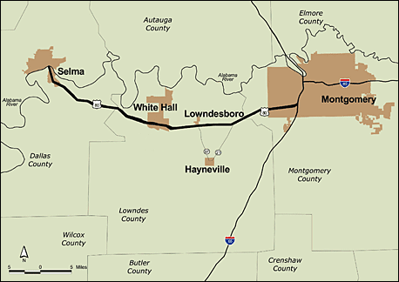
Map 1: Route of the Selma-to-Montgomery Voting Rights March (National Park Service)
Montgomery and Selma were located in the Alabama Black Belt. According to Booker T. Washington, writing in his 1901 autobiography,
So far as I can learn, the term [Black Belt] was first used to designate a part of the country which was distinguished by the colour of the soil. The part of the country possessing this thick, dark, and naturally rich soil was, of course, the part of the South where the slaves were most profitable, and consequently they were taken there in the largest numbers. Later . . . the term seems to be used wholly in a political sense—that is, to designate the counties where the black people outnumber the white.³
Questions for Map 1
1. Look carefully at this map. Where did the march route begin? Where did it end? Use the map scale to estimate the distance between the two places. If average walking speed is 3 miles per hour, how long would it take to walk that distance? Use a classroom map of the United States to locate this area.

2. In 1965, African Americans constituted about half of the population in Selma and Montgomery; in rural areas of the state 80-90 percent of the population was black. What effect, if any, do you think this fact would have had on white reactions to black attempts to gain the vote in those counties?
3. Find Dallas, Lowndes, and Montgomery counties. Selma is located in Dallas County; Montgomery, the State capital, is in Montgomery County. Only 2 percent of eligible African Americans in Dallas County were registered to vote in 1965, and there were no registered black voters in Lowndes County. How do you think a successful voting rights campaign might affect this part of the Black Belt?

4. Locate the Alabama River. Selma was a wealthy city before the Civil War, shipping large quantities of Black Belt cotton down the river. By the mid-20th century, the boll-weevil had decimated the cotton trade and Selma was in decline. How do you think that fact might have affected white attitudes towards voting rights for African Americans?

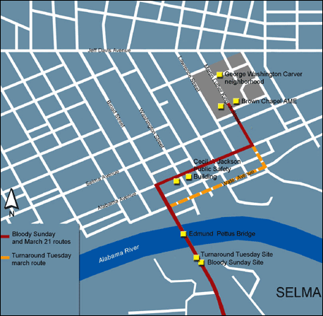

Map 2:Selma (National Park Service)
The Selma to Montgomery Voting Rights March actually consisted of three marches, all of which began at Brown Chapel African Methodist Episcopal (AME) Church in Selma. The first, on March 7, 1965, “Bloody Sunday,” ended in violence on the far side of the Edmund Pettus Bridge over the Alabama River. The second, symbolic, march took place on “Turnaround Tuesday,” March 9, and proceeded only to the site of the violence of two days earlier. After a brief prayer, the marchers turned and returned to Selma. Only the third march, which began on March 21, reached the Alabama State Capitol in Montgomery.

Questions for Map 2
- Brown Chapel is at the edge of the George Washington Carver neighborhood, a large public housing project constructed after World War II for African Americans. What effect do you think this location might have had on the role the church played in the Voting Rights March?

- Selma was a segregated city in 1965. Find Alabama Avenue, which was the main white business street. Next locate Franklin Street, where most African-American businesses were located; it is the unidentified street running parallel to Washington Street. The institutions of local government were also on Alabama Avenue, including the Dallas County Courthouse (not shown on the map) and the building housing both the Selma City Hall and the Dallas County jail. Find this building, now called the Cecil C. Jackson Public Safety Building, on the map. Why do you think organizers decided to march down Alabama Avenue on March 7 and March 21?

Determining the Facts
Reading 1: Alabama Literacy Test
In the summer of 1964, the Southern Christian Leadership Conference (SCLC), Student Nonviolent Coordinating Committee (SNCC), and the Conference on Racial Equality (CORE) conducted massive registration drives in the South. Met with violent resistance—including the murders of three civil rights workers in Philadelphia, Mississippi—these drives had only limited success.
African-American citizens in Selma conducted their own registration drives. The Dallas County Voters League (DCVL) had been founded before World War II and reinvigorated after the war by Samuel Boynton, its second president. Boynton, his wife Amelia, and DCVL member Marie Foster held classes to help African Americans in Dallas County pass the literacy tests required for voter registration, but were hampered by a pervasive fear of reprisals from the white community. In 1963, Dr. F. D. Reese, President of the DCVL, asked SNCC for assistance. Mass meetings addressed by Martin Luther King, Jr., and other civil rights leaders and organized marches to the Dallas County Courthouse to register to vote had some success. By 1964, 2.2% of African Americans over 21 were registered to vote in Dallas County; there were no registered black voters at all in neighboring Wilcox and Lowndes counties.
Between August 1964 and July 1965 the State of Alabama used 100 different literacy tests to make it difficult for people to "study" for the test. Applicants were asked to pick a test at random from a loose-leaf notebook. The sample test below was used by Rufus A. Lewis in voter education classes for African Americans that he led in Montgomery in the 1960s:
Questions for Literacy Test
- What questions do you find confusing or out of place on a test for voting?

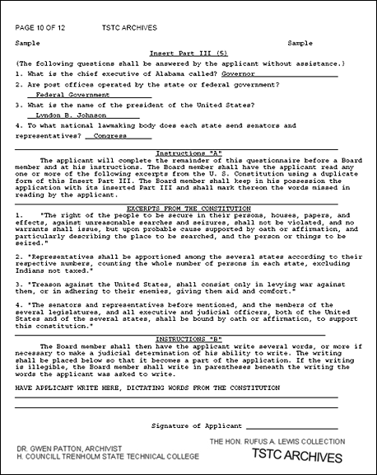
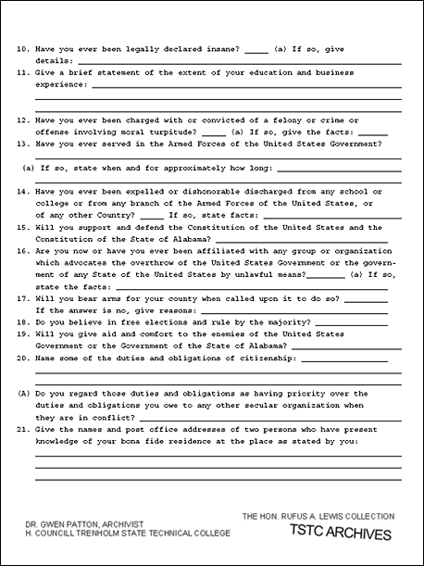
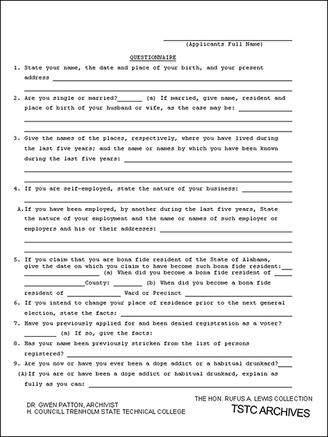

Reading 2: Selma
This reading consists of selections from oral histories taken in 1990 and 1991 from participants in the Selma to Montgomery voting rights marches of March 7, March 9, and March 21-25, 1965. The repetitions and grammatical errors commonly found in oral history transcriptions have not been corrected:
Marie Foster (Selma resident, active in the Dallas County Voters League): I called Amelia Boynton [and] we met the 23rd day of January, 1963. I said, "Well how about this, let's start a citizenship class." I said, "And we publish it, we advertise through the churches and by telephone and just personal contact, and just beg people to please come to the class, that we're going to make sure that they'll be able to fill out the applications correctly." Well anyway, one person came with all that publication. That Thursday night, the same person came back and brought a relative, and that was two people, and then so on. And I was very successful with that citizenship class.
John Lewis (head of the Student Nonviolent Coordinating Committee in 1965): So Dr. King received the Nobel Peace Prize in December 1964, and right after returning from Europe he, in a conversation with President Johnson, he said, "We need a Voting Rights Act. We need a strong Voting Rights Act." And President Johnson and people in the administration said in effect Dr. King, you know, we just signed the Civil Rights Act of '64 and it's just going to be impossible to get another. And so Dr. King said to us, "Well we will write that act. We will write that act."
C. T. Vivian (National Director of Affiliates for the Southern Christian Leadership Conference in 1965): So the thing is, you've got to make the nation understand what's happening, which means that you've got to have the press. We made national television and national television made us. You see what I mean? We made national television news something that people wanted to see every day. Television was made for us, because we're action-oriented. We didn't become action-oriented for the sake of the TV, we became action-oriented because that's nonviolent direct action.
John Lewis: In certain points of Alabama during those years, especially in the Black Belt and in Dallas County, it was just almost uncontrollable fear. You knew if you went to Selma, some of the surrounding areas and towns and community, it was like putting your life on the line. It was very risky. People had some real reservations about getting involved in places like Selma.
Jamie Wallace (reporter for the Selma Times Journal in 1965): People ask me a lot of times why Selma was chosen. You know, Memphis would have been an excellent target or Jackson, Mississippi, or heaven forbid even Chicago. I think a lot of factors contributed, plus the fact that you had a sheriff and a circuit judge here who they knew would resist. And unfortunately that's what occurred.
C. T. Vivian: Now, there are a number of things about Selma that are most interesting. Number one was that they had had a political struggle going on directly related to voter enfranchisement over a period of years. Plus the fact that because of that struggle they had more people registered than any other county around. Half the population, . . . a little over half actually, of the population was black. We did know about Sheriff Clark. But what we really were counting on was not just Sheriff Clark, which some of the sources give you, but the fact that that place was truly racist. . . . But the important thing was an organized group. The Dallas County Voters League was going to make the difference. Because there you had Mrs. Boynton and Reese, who were true leaders of the community, long-time engagement.
F. D. Reese (Selma resident, President of the all-black Selma City Teachers Association, and President of the Dallas County Voters League in 1965): In July 1964 [Circuit Judge James Hare]wrote an injunction. If five or more people were found congregating on the streets discussing the right to vote, they would be arrested. And so that really put a damper on the movement from July 1964 until January the 2nd, 1965. In December 1964 I signed the invitation for Dr. King and SCLC to come into Selma to assist us as we pursued the right to vote, which would include breaking that injunction. On January the 2nd the [Brown Chapel AME] Church was packed. And when the law enforcement officers came and saw such a large crowd of people at that meeting, nothing was mentioned about arresting anybody. And so that did away with the injunction. And from that point on we then resumed our meeting nightly.
Hosea Williams (National Director of Voter Registration and Political Education for the SCLC in 1965): I went down [to Selma] the first of January, then I started all these marches and taking folks to jail and sitting-ins and pickets and filling up the jail. And Jim Clark was kind of like made for me. Jim Clark was a road model racist. First he was big and muscular and handsome, and he dressed immaculately. The next thing, Jim Clark, I'm sure he had a mental problem because he'd lose control. Jim Clark couldn't see from the other movements that what he was doing to us was not only playing into our hands but going to bring the nation down on him. He couldn't see that. I don't think there was a racist in the South that was made more proper for Martin Luther King's nonviolent movement than Jim Clark.
John Lewis: Sheriff Jim Clark was a big man. Big hat, big man, nightstick. And a lot of people were afraid of him, not just black citizen but also white citizen.
F. D. Reese: Had Jim Clark been another person, we would have not reached the goal we did at such speed as we did.
John Lewis: The first mass demonstration in 1965 was on January the 18th, and it was my day to lead a group of people to the Dallas County courthouse. And I will never, ever forget that day. Several hundred people left Brown Chapel AME Church and we walked to the Dallas County Courthouse, very orderly, just a quiet march of people attempting to get to the courthouse and go in and take the literacy test. And we got to the steps of the courthouse. And [Sheriff Jim Clark] walked up to the head of the line and said, "John Lewis, you're under arrest," and he took me to jail. And several other people got arrested and went to jail, and just a whole series of demonstrations started then.
F. D. Reese: I recommended that we would engage in a teachers march on January the 22nd, 1965, on a Friday. Well, there were many people that thought that that never would happen. On that Friday when I got on campus at Clark [Elementary] School, only one car was there, but then cars started coming in, parking, and we had 99 percent participation. When those teachers filed out of that schoolhouse, I saw parents shouting, some were crying, students were shouting, because they felt that now teachers who were looked up to by students and by parents have made a decision to go and become involved.
Jamie Wallace: So [Jim Clark and Wilson Baker, Selma’s Public Safety Commissioner] did effect an agreement. The city police would have jurisdiction over the city, the sheriff would have jurisdiction on the courthouse square and the city would have jurisdiction to the bridge, where the city limits end. So demonstrators were handled much differently in the city than they were handled in the county or on the courthouse square.
John Lewis: [In February] a young man by the name of Jimmie Lee Jackson was shot in a little town called Marion, Alabama, north of Selma. This young man was shot in the stomach and he died.
Albert Turner (Marion resident and head of the Perry County Civic League in 1965): So we decided after they killed Jimmie [in February], that we were going to take Jimmie's body to the state capital, and dump it on the steps. And Dr. King said to us then that he thought that all of us ought to organize, and go to Montgomery in a mass. We were just kind of like in war, to be frank with you, and we were determined, really, to break the system down.
We had a long caravan of cars that came down that Sunday morning [March 7] from Marion, we came with our clothes and our lunch. And once we got here, we found out that Dr. King had decided that we were not going to Montgomery that day. I understand it now, there was no logistical way we could go out and march. We had no tents, no food. Nobody had made no arrangements, or nothing like this. But we from Perry County didn't know all of this. And I had so many people, and had been trained that you never get people that ready, and don't do nothing. So in all fairness, I was the individual who seriously insisted we had to march in some form or fashion that day, to keep from killing the movement. We called Dr. King and told him what the situation was and we explained to him why we had to walk.
John Lewis: as an individual and as chairman of SNCC I took the position that we should march from Selma to Montgomery. We had to somehow take the message to Governor Wallace, that we had to have a showdown in Alabama. The Executive Committee of the Student Nonviolent Coordinating Committee [as a whole] opposed the idea of the march, but said, well, you can march as an individual but not as chairman of SNCC.
Albert Turner: So Hosea and John Lewis led that day as SCLC and SNCC and I walked second. I guess if I had to tell the truth, it probably was the most fearful march I ever had. That's the one day we knew what was going to happen to us before we left. And Jimmie was already killed, so we expected some more to be killed.
Jamie Wallace: It was obvious to those of us in the media that this was to be a symbolic gesture. It was not a serious march to Montgomery. Ladies had on high-heel shoes, the absence of Dr. King and the national media and so forth. So we felt like it was strictly a symbolic gesture to cross a bridge, go to a point about 100 yards beyond the bridge and probably turn around and come back, and be able to say that we did it even though they told us not to do it.
Amelia Boynton (Selma Resident, widow of Samuel Boynton and active in the Dallas County Voters Leagues in 1965): So that Sunday morning I went immediately to the church. I had on high-heel shoes, because at that time I didn't wear low-heel shoes. I started out with the rest. Marie Foster and I were in the front. And just before we got to the light across the [Edmund Pettus] bridge, we saw that the road was blocked. I didn't think anything was going to happen, but as we approached, it was announced, "Don't go any farther." And when Hosea Williams said, "May I say something?" Clark said, "No, you may not say anything. Charge on them, men!”
And they started beating us. They had horses. And I saw them when they were beating people down, and I just stood. Then one guy hit me with the nightstick, I think it was a nightstick. He hit me with the nightstick just back of the head and down toward the shoulder. And I still stood up there. Then the second lick was at the base of the neck. And I fell. I think that was the ambulance that came from Anderson Funeral Home that took me to the church and tried to revive me but could not revive me. So they took me to the Good Samaritan Hospital. And when I was revived, I really didn't know where I was, but I was there several hours before I really came to.
Hosea Williams: So when we got over the bridge—well I'll tell you, it was one of the most gratifying and most memorable moments of my whole life. I don't think I ever seen Americans more ready and willing to suffer and sacrifice for dignity, for human dignity, in my whole life. (inaudible). And I was just like crying inside, laughing, I'm just so happy to see all of those people just, let's go, let's go.
So we go ahead across the bridge, then we come to the confrontation after we cross the bridge. And I don't know where I've seen that many cops and state troopers and militia men. Al Lingo was the Public Safety Commissioner. He said, "Halt!" So we stopped. And he said, "Take them niggers back home." Now, I finally mustered up enough grit and grime to open my mouth. I said, "Sir, may we have a word with you?" And he said, "There will be no talking today. I said take them niggers back to the church. You got one minute." I looked at my watch, and 15 seconds he said, "Charge." So they knocked me right down. They first beat us down with billy clubs, then they gassed us. It was a military attack. And then I saw those horses. And I was there, I said, Oh my god, how many people did I lead to their death today?
John Lewis: So they came toward us, pushing and trampling us with the horses and beating, and then they released the tear gas. And I was just there choking, choking, and I felt like it was the last demonstration. I was clubbed down and I suffered a concussion.
Jamie Wallace: Well, when we topped the bridge, I could see that there was a formidable line of troopers beyond, about a hundred yards beyond the bridge. Major John Cloud, who was head of the state troopers, told them they could not march beyond that point, to turn around and go back. And at some point, pushing and shoving started. And of course the troopers moved in and started a panic, because when you pushed against them with those billy clubs, people started falling, they started grasping at the clubs, and then they started using the clubs in a different sort of way. And then they started firing tear gas. And of course that really set off a panic.
Anything could have happened at that point. They had a collection of onlookers over there in the back of trucks and so forth watching what was happening, and we didn't know how many of those might get involved in it, which fortunately they didn't. There were very few times during the whole movement that I ever was afraid, but that was one day that I was physically afraid. Plus I was also very angry.
The national media was not here that day, but WSFA in Montgomery, I believe, ended up with the footage that you've seen shown thousands and thousands of times since then. It did make the national news that night, and of course immediately there was an outpouring of support from across the nation.
Jamie Wallace: Well let me describe that night. The leadership, the Southern Christian Leadership Conference, had to do an excellent job that night to contain the people because they were so angry. [When] they re-grouped at Brown Chapel, the anger so welled up we really feared that there might be a spontaneous violence that night. But they did a really good job of talking the temperature down some. And it didn't happen.
John Lewis: All over the United States, the people saw what happened on television, they read about it in the newspaper, and there was demonstration after in Washington, every major city in America, and some of our embassies abroad. And Dr. King issued a call, issued an appeal for the religious leaders of America to come to Selma.
Hosea Williams: People came all the way from Hawaii and Canada. We grew from 700 to 7,000 in 48 hours. So we went on to a meeting place in Selma. What do we do right now?
C. T. Vivian: We had to act, and we were action people. But at the same time, [Federal Court] Judge Johnson had not acted [on whether a march to Montgomery would be permitted]. So how do we get a way out of this and yet be in it, so we can give more time for those other kinds of decisions to be made? Then if they did not make them, then we would go on and move. So the issue was to be able to go across that bridge and do what we needed to do, and to force the hand of the federal government to have to act. After all, it was only right and decent to give Johnson that chance to do the right thing.
F. D. Reese: So in order to try to pacify all these folk coming down to march, we would organize a march and we would march to the point of confrontation across the bridge, and then we'll march back to the church. So all that was done [on March 9] to try to give the court and Montgomery Judge Johnson an opportunity to make a decision on whether or not we had the right [to march to Montgomery]. So we got that ruling [on March 19] and it was on the 21st that we then proceeded on that march.
Hosea Williams: We were mobilizing fast—we had had marches before but never a march of that magnitude. We began organizing staff plus volunteer supporters in the various departments: food, medical department, program, mobilization, legal redress (had more lawyers than we ever needed), housing (these huge tents), transportation (taking people back to Montgomery or back to Selma), celebrity, communication department. We had it planned out, we knew exactly what time we'd leave that morning, we knew exactly where we'd stop for the ten o'clock break, we knew exactly where we'd stop for lunch, we knew exactly where we'd stop in the afternoon and what time.
John Lewis: I think the day we left Selma was on a Sunday afternoon, March 21st. It was like the beginning of a holy crusade. You know, President Johnson called out the military to protect the marchers along the way, and as we walked that next day, you saw the men of the Army, in their fatigues, guarding the way with their guns drawn. They stayed with us all the way from Selma [to Montgomery].
C. T. Vivian: I join everybody as we go across the bridge. By the time I get to the top of the bridge where you can see everything, that long line, so wide and big and beautiful. It's way, way, way down there. And you could see it, and boy it was beautiful. I mean it's—hey, it's one of the most—just festive, joyful, celebration, to use the great religious term. It was celebration. And a great time.
Albert Turner: It was my responsibility to be very sure that there were no incidents. We had to work very hard, without it being known, without it being obvious, to keep incidents from happening. So don't think that we just walked out on the streets and waved some magic wand and everybody was nonviolent. That's a joke. But we had a system that kept violence down.
John Lewis: The night before the final day, we reached [the City of] St. Jude [Hospital complex in Montgomery]. And at night, several entertainers from all around the country, like Peter, Paul and Mary, Harry Belafonte, Sammy Davis, Jr., Johnny Mathis came and performed for the marchers and for all of the people that were gathering.
People started gathering that night and hundreds and thousands of people started coming in from all over the country. And by the next morning [March 25], when we finally got ready and line up, there were major civil rights leaders, religious leaders representing every conceivable denomination or religious group.
F. D. Reese: The next morning we grouped and lined up and marched onto the capitol. This is history, you know what I mean?
Amelia Boynton: They had gotten about a mile I guess from Saint Jude. Then I stood on the side, and I said to myself, "I'm going to get on this march somewhere." And Dr. King happened to see me. And he said, "Come on in, Mrs. Boynton." Well I had the chance to get on the front line. After everything was over, we formed a committee to take the grievance to the governor, who wasn’t even to be seen.
Hosea Williams: And we had organized to the best of our ability. I can't think of another time in the civil rights movement when the staff was so committed and worked so hard, and there was no playing around. I never will forget when the program ended and I guess about 45 minutes I walked out on those grounds and I was really crying and everybody had gone. And just a lot of people and just the wind blowing. It just looked like—it was really a miracle. . . . (inaudible) it was like a miracle.
Then I went back inside the [Dexter Avenue Baptist] church [in Montgomery]. The girl came out screaming, saying I had a telephone call. And Mrs. Liuzzo, who had been down there about three or four days, they killed her. And so that threw us back in gear.
But I don't think anything has happened in America that shook the conscience of this nation. I don't think there's anything that's ever happened in the history of America that has more awakened America and developed as much support [as] that Selma to Montgomery march.
Questions for Reading 2
- What factors led to Selma’s selection as the place to begin the SCLC voting rights campaign? Which do you think was the most important?

- Who remembered being afraid? What were they afraid of? How do you think you would have reacted to the events described in this reading?

- George Wallace was elected governor of Alabama in 1962 on a platform of “segregation now, segregation tomorrow and segregation forever.” In the summer of 1963 he defied the Federal government’s order that the University of Alabama admit two African-American students. By 1965 he had become a national symbol of resistance to civil rights. Why do you think John Lewis thought it was so important to “take the message to Governor Wallace”?

- Viola Liuzzo, who is mentioned by Hosea Williams, was a white housewife from Detroit who came down to help the marchers. She was driving a black man from Montgomery to Selma on March 25 when four Ku Klux Klansmen passed her car and shot her and her passenger (who survived). She was one of three people killed during the course of the voting rights campaign in Selma; the other two were Jimmie Lee Jackson and James Reeb, a Unitarian minister who was beaten in Selma and died of his injuries. How do you think these deaths would affect public opinion? Jimmie Jackson’s death was not well publicized, in part because it was early in the campaign and took place in a small town not covered by the media. Rev. Reeb’s and Mrs. Liuzzo’s deaths were covered nationally. Many African Americans saw this as another instance of discrimination because the deaths of two white people were treated as major news, while no one seemed to care about the death of a young black man.

- This reading was put together from a group of oral histories that were taken 25 years after the event. It only includes what these individual people remember and omits some events that would be included in a scholarly history of the march. What do you think might be some of the advantages of using oral histories? What might be some of the disadvantages?

- The oral histories used for this reading were taken from individuals directly involved in planning the Selma to Montgomery March. How do you think the stories of other people who participated in or observed the march, many of which have been recorded, might add to your understanding of the events of March 7-25, 1965?

Visual Evidence
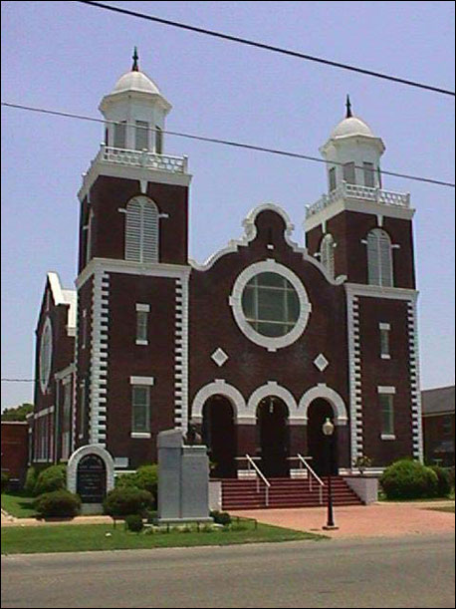
Photo 1: Brown Chapel AME Church
(Alabama Historical Commission)
Questions for Photo 1
1. Look at this image carefully and describe what you see in your own words. What does the size and design of this building suggest about the importance of the church in Selma’s African-American community?

2. Review Reading 2 they mention Brown Chapel (often called simply “the church”) many times. What occurred there?

3. The congregation at Brown Chapel voted to allow their church to be used for the voting rights campaign, but some other congregations voted against participation. Why might other churches have wanted not to be involved? Why might Brown Chapel have agreed? What advantages might Brown Chapel have had as a center of the movement (refer to Map 2, if necessary?

4. Christian ministers, including Andrew Young, Martin Luther King, Jr., Ralph Abernathy, C. T. Vivian, and Frederick Reese, played important roles in the civil rights movement. Why do you think that was the case?

Photo 2: Marchers and State Troopers, March 7, 1965
(Federal Bureau of Investigation)
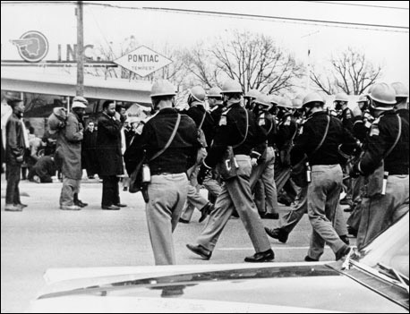
Photo 3: “Bloody Sunday”
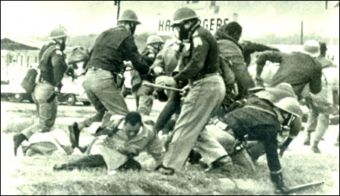(Library of Congress)
Questions for Photo 2
1. Examine these photos carefully. It might be useful to divide them into sections and to list everything you see in each section. What is happening here? You may want to go back to Reading 2 to reconstruct the events of the march and the troopers’ attack. At what point in the action do you think each photo was taken?
2. The man in the dark raincoat at the left center of Photo 2 is Hosea Williams. In Photo 3, the man in the light raincoat is John Lewis. Can you find him in Photo 2? In what ways do these photos add to their accounts of the march in Reading 2?
3. Photo 2 was taken by an FBI observer. Many people have criticized the Federal government for not allowing these observers to intervene to prevent violence. None of the newspaper photographers recording the march took action to prevent the violence either. Do you think they should have? What do you think you would have done if you had been there?
4. Photo 3 is blurry because it was taken by a photographer standing some distance away using a telephoto lens. Why do you think the reporter didn’t get closer to the marchers, even though he probably could have gotten a clearer picture?

5. Imagine that you are watching TV on Sunday night or reading a newspaper Monday morning and seeing images like these. How do you think you would react?

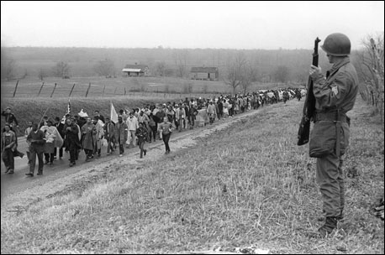
Photo 4: On the road to Montgomery, March 22 or March 23
(© Spider Martin. All rights reserved. Used by permission.)
Questions for Photo 4
1. This photo shows the marchers in rural Lowndes County, where the road to Montgomery, was only two lanes wide. Judge Johnson had ruled that no more than 300 people could march in this section. Why do you think he made that ruling?

2. According to Hosea Williams, the division of the Alabama National Guard that was ordered to protect the march, was the same unit that attacked the marchers on Bloody Sunday. How do you think the guardsmen would have felt about their current assignment? How do you think the marchers would have felt?

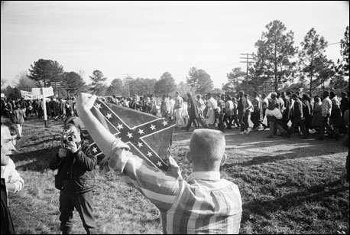
Photo 5: Onlookers along the route to Montgomery.
(© Bettmann/CORBIS)
Questions for Photo 5
1. This photo shows some of the people lined up to watch the marchers pass. Why do you think they were there? The flag the man is displaying is the flag of the Confederacy. What do you think it represents for him and for the marchers?

2. Does the body language of the man holding the flag suggest anything about his attitude towards the marchers?
3. In Reading 2, Jamie Wallace says that they were worried about what the people along the road might do during the march of March 7. What do you think he was afraid of? On March 7 there were only a few hundred marchers. If you were one of the people marching on that day, how do you think you would feel about people like this? This photo was taken sometime between March 21 and March 25. How do the marchers in this photo seem to be reacting to the by-standers? Based on Photo 4, what factors do you think might have affected their attitude?

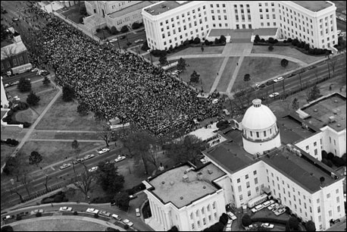
Photo 6: View of Martin Luther King, Jr., addressing the marchers at the Alabama State Capitol in Montgomery.
(© Bettmann/CORBIS)
Questions for Photo 6
1. King was not allowed to speak from the steps of the Capitol. Can you find the line of state troopers that blocked the way? Why do you think he was not allowed to stand on the steps to speak to the crowd?

- One of the reasons people wanted to march from Selma to Montgomery was to present a petition to Governor George Wallace. Wallace was in his office watching the crowd as King was speaking. Why do you think he refused to meet with the marchers? Wallace’s aides reportedly commented that he was looking at the inaugural crowds of the future. What do you think the aides meant by their comment?

3. Look closely at the flags flying over the dome of the Capitol Building. In 1861, the earliest part of this building served as the first capitol of the Confederacy. In 1965 it was flying the Confederate flag right below the Alabama state flag. Why do you think a U.S. state capitol building would fly the Confederate flag?

4. King’s speech was covered by all major radio and television networks. The speech was a famous one—quoting the Battle Hymn of the Republic in referring to the voting rights campaign. Why do you think the march and King’s speech were considered so important?

