Jacob Riis
AMERICAN JOURNALIST
WRITTEN BY:
The Editors of Encyclopædia Britannica
See Article History
Alternative Title: Jacob August Riis
Jacob Riis
AMERICAN JOURNALIST
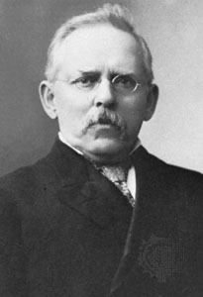
Jacob Riis, in full Jacob August Riis (born May 3, 1849, Ribe, Denmark—died May 26, 1914, Barre, Massachusetts, U.S.), American newspaper reporter, social reformer, and photographer who, with his book How the Other Half Lives(1890), shocked the conscience of his readers with factual descriptions of slum conditions in New York City.
Riis immigrated to the United States at the age of 21 and held various jobs, gaining a firsthand acquaintance with the ragged underside of city life. In 1873 he became a police reporter, assigned to New York City’s Lower East Side, where he found that in some tenements the infant death rate was one in 10.
By the late 1880s, Riis had begun photographing the interiors and exteriors of New York slums with a flash lamp. Those photos are early examples of flashbulb photography. Riis used the images to dramatize his lectures and books, and the engravings of those photographs that were used in How the Other Half Lives helped to make the book popular. But it was Riis’s revelations and writing style that ensured a wide readership: his story, he wrote in the book’s introduction, “is dark enough, drawn from the plain public records, to send a chill to any heart.” Theodore Roosevelt, who would be elected U.S. president in 1900, responded personally to Riis: “I have read your book, and I have come to help.” The book’s success made Riis famous, and How the Other Half Lives stimulated the first significant New York legislation to curb tenement house evils. It also became an important predecessor to the muckraking journalism that took shape in the United States after 1900.

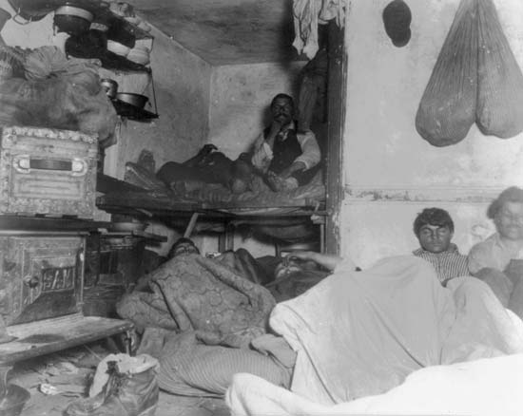Riis, Jacob: shelter for immigrants in a New York City tenement
Shelter for immigrants in a New York City tenement, photograph by Jacob Riis, 1888.

