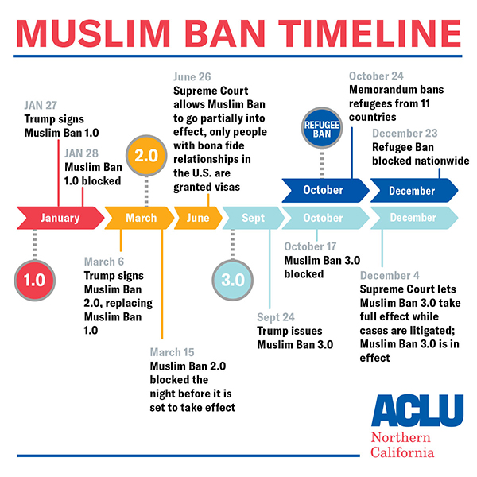
Immigration Ban Timeline

January 27, 2017 - Trump Signs First Muslim Ban, Sparks Airport Protests Nationwide
Trump's Executive Order 13769 suspends entry into the U.S. for everybody from Iran, Iraq, Libya, Somalia, Sudan, Syria, and Yemen for 90 Days; all refugees for 120 days; and Syrian refugees indefinitely. Sparks three days of protests at airports across the nation.
Status: Muslim Ban 1.0 takes effect immediately. Travelers detained at airports, including green card holders from the designated countries and holders of valid visas. Refugees who had been booked for travel to the United States have their travel plans canceled at the last minute.

January 28, 2017 - Two ACLU Lawsuits Filed, First Court Victory
Second day of airport protests. Suits filed in New York and Massachusetts. A federal judge in New York grants the ACLU's request for an emergency stay to prevent the deportation of all people stranded in U.S. airports under President Trump's Muslim Ban.
Suit: Darweesh v. Trump — Eastern District of New York
Suit: Louhghalam v. Trump — District of Massachusetts
Ruling: Darweesh v. Trump — Eastern District of New York
What's changed: People who arrive at a U.S. airport with a valid visa, green card, or as refugees approved for resettlement to the United States are protected from deportation.
Status: Muslim Ban 1.0 partially blocked.

January 29, 2017 - Second Court Victory, Muslim Ban Partially, Temporarily Blocked Nationwide
A federal district court in Massachusetts issues a temporary restraining order that prohibits the government from relying on Executive Order 13769 to detain or remove anyone who is otherwise legally authorized to enter the U.S.
Ruling: Louhghalam v. Trump — District of Massachusetts

What's changed: People who arrive at a U.S. airport with a valid visa, green card or as refugees approved for resettlement to the United States are allowed to enter the United States. However, people from the targeted countries are still not able board planes into the U.S.
Status: Muslim Ban 1.0 partially and temporarily blocked until Feb. 5, 2017
January 30, 2017 - Trump Fires Attorney General Yates. New Lawsuit Filed Against Ban
President Trump fires Sally Yates after she defies him and refuses to enforce the Muslim Ban.
At present, I am not convinced that the defense of the executive order is consistent with these responsibilities nor am I convinced that the executive order is lawful.
— Attorney General Sally Yates
On the same day, the State of Washington files a suit challenging Trump's Muslim Ban. The ACLU submits an Amicus Brief in support.
Suit: Washington v. Trump — Western District of Washington
Status: Muslim Ban 1.0 still partially blocked until Feb. 5, 2017

February 02, 2017 - 50 ACLU Affiliates File Freedom of Information Act Requests
Fifty ACLU affiliates file 18 coordinated Freedom of Information Act requests with local U.S. Customs and Border Protection offices to find out whether federal immigration officials are defying nationwide federal court orders at airports across the country.
Status: Muslim Ban 1.0 still partially blocked until Feb. 5, 2017

February 03, 2017 - Judge Issues New Nationwide Order Fully Blocking Muslim Ban
A federal judge in Seattle issues new nationwide order fully blocking the Muslim Ban on the same day that the previous ruling is set to expire.
Ruling: Washington v. Trump — Western District of Washington
What's changed: U.S. Customs & Border Protection (CBP) begins to let people board planes into the U.S.
Status: Muslim Ban 1.0 temporarily blocked

February 07, 2017 - ACLU Sues Trump on Behalf of Refugees and Families
The ACLU sues President Trump, arguing that the Muslim Ban intentionally discriminates against Muslims and violates the U.S. Constitution's guarantees of freedom of religion and equal treatment under the law.
Suit: International Refugee Assistance Project (IRAP) v. Trump — District of Maryland
Status: Muslim Ban 1.0 still temporarily blocked

February 09, 2017 - Court Rejects Trump's Appeal, Refuses to Reinstate Muslim Ban
A three-judge panel in the Ninth Circuit denies the Trump Administration's appeal of the Washington court's order and unanimously refuses to reinstate Trump's Muslim Ban.
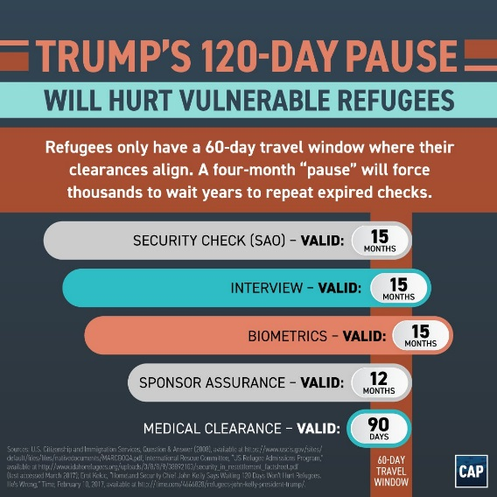
Ruling: Washington v. Trump — Ninth Circuit Court of Appeals
Status: Muslim Ban 1.0 still temporarily blocked

March 06, 2017 - Trump Signs Muslim Ban 2.0
Trump signs Executive Order 13780, suspending entry into the U.S. for everybody from Iran, Libya, Somalia, Sudan, Syria, and Yemen for 90 Days; all refugees for 120 days; and Syrian refugees indefinitely.
What's changed: The ban now exempts those who already have visas and green cards and removes Iraq from the list of banned countries.
Status: Muslim Ban 2.0 set to take effect on March 16, 2017

March 08, 2017 - State of Hawaii Challenges Muslim Ban 2.0
The State of Hawaii sues President Trump, arguing that Muslim Ban 2.0 is unconstitutional.
Suit: Hawaii v. Trump — District of Hawaii
Status: Muslim Ban 1.0 still temporarily blocked pending further court proceedings. Muslim Ban 2.0 set to take effect on March 16, 2017.

March 15, 2017 - Muslim Ban 2.0 Suffers First Defeat
A federal district court in Hawaii blocks Muslim Ban 2.0 the night before it is set to take effect.
Ruling: Hawaii v. Trump — District of Hawaii
What's changed: Muslim Ban 2.0 is prevented from taking effect, so applicants for visas and refugee status from Iran, Libya, Somalia, Sudan, Syria, and Yemen continue to have their applications processed normally.
Status: Muslim Ban 2.0 blocked nationwide.

March 16, 2017 - ACLU Triumphs in Court, Dealing Muslim Ban 2.0 Second Defeat in 24 Hours
In a separate challenge to the Muslim Ban, a federal district court in Maryland rules in favor of the ACLU and issues a second order blocking the Muslim Ban nationwide.
Ruling: IRAP v. Trump — District of Maryland
Status: Muslim Ban 2.0 still blocked nationwide

May 25, 2017 - Fourth Circuit Rules in Favor of ACLU, finds Muslim Ban 2.0 Unconstitutional
In a 10-3 ruling, the Fourth Circuit Court of Appeals upholds the lower court's decision in Maryland and rules Muslim Ban 2.0's visa restrictions unconstitutional.
Ruling: IRAP v. Trump — Fourth Circuit of Court of Appeals
Status: Muslim Ban 2.0 still blocked nationwide.

June 12, 2017 - Ninth Circuit Unanimously Blocks Muslim Ban
The Ninth Circuit Court of Appeals unanimously upholds the lower court's ruling in Hawaii blocking Muslim Ban 2.0. Upholds the injunction blocking the ban on both refugees and visa holders.
Ruling: Hawaii v. Trump — Ninth Circuit of Court of Appeals
Status: Muslim Ban 2.0 still blocked nationwide.

June 26, 2017 - Supreme Court Agrees to Review Challenges to Muslim Ban
The U.S. Supreme Court rules that it will hear challenges to the Muslim ban. In the meantime, the Supreme Court allows a narrowed version of Muslim Ban 2.0 to go into effect.
Ruling: IRAP v. Trump & Hawaii v. Trump — U.S. Supreme Court
What's changed: The ban takes effect for refugees worldwide and persons from Iran, Libya, Somalia, Sudan, Syria, and Yemen,unless they have a "bona fide relationship" with a person or entity in the United States.
Status: Muslim Ban 2.0 will go partially into effect on June 29, 2017

June 29, 2017 - President Trump issues 'Grandma Ban'
The Trump Administration issues guidance on the implementation of the Muslim Ban 2.0.
What's changed: Under the Trump Administration's guidance, "bona fide relationships" do not include grandparents, grandchildren, aunts, uncles, nieces, nephews, cousins, brothers-in-law, or sisters-in law.
Status: Muslim Ban 2.0 is partially in effect.

July 13, 2017 - Federal Court Rejects Trump's 'Grandma Ban'
A federal judge in Hawaii rejects the Trump Administration's extremely narrow definition of "bona fide relationship."
Ruling: Hawaii v. Trump — District of Hawaii
What's changed: The definition of "bona fide relationship" now includes grandparents, grandchildren, aunts, uncles, nieces, nephews, cousins, brothers-in-laws, and sisters-in-law. Also, refugees with a "formal assurance" from a U.S. resettlement agency agreeing to oversee their resettlement in the United States are now exempt from the ban, and can travel to the United States.
Status: Muslim Ban 2.0 in effect, but people with a "bona fide relationship" to a person or entity in the U.S. are exempt from the ban.

July 19, 2017 - U.S. Supreme Court Rejects Trump's 'Grandma Ban'
The U.S. Supreme Court issues an order in the pending case, upholding the lower court's expanded definition of bona fide relationships for family members but not for assured refugees.
Ruling: Hawaii v. Trump — U.S. Supreme Court | Read more
What's changed: Supreme Court confirms that people from the six targeted countries with grandparents, grandchildren, aunts, uncles, and other close relatives are allowed to enter the U.S. However, the Court also rules that assured refugees are not categorically exempt from the ban.
Status: Muslim Ban 2.0 in effect, but people with a "bona fide relationship" to a person or entity in the U.S. are exempt from the ban.

September 24, 2017 - President Trump issues Muslim Ban 3.0
President Trump issues Muslim Ban 3.0 through a Presidential Proclamation.
What's changed: The revised ban blocks individuals seeking visas from designated countries indefinitely. It adds Chad, North Korea, and certain government officials from Venezuela to the list of banned countries, while removing Sudan and applicants for certain nonimmigrant visas from the scope of the ban. The new ban does not address refugees, who remain subject to Muslim Ban 2.0 for one more month.
Status: The Muslim Ban goes into effect immediately for people who lack bona fide relationships to the U.S. and remains partly in effect for refugees. People with bona fide relationships will no longer be exempt from the ban starting October 18.

September 29, 2017 - ACLU Challenges Muslim Ban 3.0
The ACLU files an amended complaint in IRAP v. Trump arguing that President Trump's Muslim Ban 3.0 is just as discriminatory and unconstitutional as the previous two bans.
Suit: IRAP v. Trump — District of Maryland
Status: Muslim Ban 3.0 is in effect for individuals seeking visas who lack a bona fide relationship to the U.S. and Muslim Ban 2.0 remains in effect for refugees. Visa applicants with bona fide relationships will no longer be exempt from the Muslim Ban 3.0 starting October 18.

October 10, 2017 - Hawaii Sues, Challenges Muslim Ban 3.0
Hawaii amends its lawsuit to challenge Muslim Ban 3.0.
Suit: Hawaii v. Trump — District of Hawaii
Status: Muslim Ban 3.0 is in effect for individuals seeking visas who lack a bona fide relationship to the U.S. and Muslim Ban 2.0 remains in effect for refugees. Visa applicants with bona fide relationships will no longer be exempt from the Muslim Ban 3.0 starting October 18.

October 17, 2017 - Hawaii Wins Partial Block to Muslim Ban 3.0
Federal court in Hawaii temporarily blocks Muslim Ban 3.0 nationwide.
Ruling: Hawaii v. Trump — District of Hawaii
What's changed: Visa applicants from Iran, Libya, Somalia, Chad, Syria, and Yemen are exempt from the ban, and their applications will be processed normally. Ruling does not apply to North Koreans and certain Venezuelan government officials.
Status: Muslim Ban 3.0 blocked. Muslim Ban 2.0 remains partly in effect for refugees.

October 18, 2017 - ACLU Victorious, Muslim Ban 3.0 Loses in Court, Again. Nationwide Day of Action
The ACLU triumphs in Maryland court, temporarily blocking Muslim Ban 3.0 nationwide for people with bona fide relationships to the U.S.
Ruling: IRAP v. Trump — District of Maryland
On the same day as this ruling, Muslim Americans across the country take part in the #NoMuslimBanEver Day of Action and deliver a petition with over 100,000 signatures to Congress.
Status: Muslim Ban 3.0 blocked. Muslim Ban 2.0 remains partly in effect for refugees.

October 24, 2017 - Trump Administration Issues Ban on Refugees from 11 Countries
President Trump issues a Proclamation reinstating the U.S. Refugee Admissions Program, but also authorizing the Department of State and the Department of Homeland Security to ban certain refugees. At the same time, three agency heads issue a memorandumeffectively banning refugees from 11 countries, most of which are Muslim-majority, and suspending the processing of follow-to-join refugee applications.
What's changed: Muslim Ban 3.0 and the Refugee Ban both target groups that were covered by the original Muslim ban. Muslim Ban 3.0 targets people from Iran, Libya, Somalia, Chad, Syria, and Yemen while the Refugee Ban blocks refugees from Egypt, Iran, Iraq, Libya, Mali, North Korea, Somalia, South Sudan, Sudan, Syria, and Yemen, as well as follow-to-join applications from family members of refugees.
Status: Muslim Ban 3.0 still temporarily blocked, but the Refugee Ban is in full effect.

November 06, 2017 - ACLU Challenges Refugee Ban
The ACLU of Washington challenges the Trump Administration's Refugee Ban targeting refugees from 11 countries.
Suit: Doe v. Trump — District of Washington
Status: Muslim Ban 3.0 still temporarily blocked, but the Refugee Ban is in full effect.

December 04, 2017 - Supreme Court Allows Muslim Ban to Take Full Effect
The U.S. Supreme Court grants the Trump Administration's request to temporarily allow Muslim Ban 3.0 to immediately take full effect as the lawsuits are being litigated. The ban affects 150 million people, the vast majority of whom are Muslim.
Ruling: Hawaii v. Trump & IRAP v. Trump — U.S. Supreme Court
What's changed: Visa applications from Iran, Libya, Somalia, Syria, Yemen, North Korea, Chad, and certain government officials from Venezuela will be denied, with limited exceptions for nonimmigrant visas from certain countries. People who had a valid visa before the ban took effect are still allowed to enter.
Status: Muslim Ban 3.0 and the Refugee Ban in full effect.

December 08, 2017 - ACLU of Northern California Challenges Refugee Ban
The ACLU of Northern California amends its lawsuit to challenge the discriminatory refugee restrictions in the Refugee Ban.
Suit: Roe 1 v. Trump — Northern District of California
Status: Muslim Ban 3.0 and the Refugee Ban still in full effect.

December 22, 2017 - Ninth Circuit Upholds Block on Ban, But Ruling on Hold Pending Litigation
The Ninth Circuit upholds lower court's ruling blocking Muslim Ban 3.0. However, due to the Supreme Court's order on Dec. 4, the ban remains in effect while the cases are being litigated.
Ruling: Hawaii v. Trump — Ninth Circuit Court of Appeals
Status: Muslim Ban 3.0 and the Refugee Ban still in full effect.

December 23, 2017 - Court Blocks Refugee Ban
Federal district court issues nationwide injunction blocking the Refugee Ban.
Ruling: Doe v. Trump — District of Washington
Status: Muslim Ban 3.0 still in full effect, but the Refugee Ban is blocked nationwide.

Citation: Abramson, Larry, and Maria Godoy. “The Patriot Act: Key Controversies.” NPR, NPR, 14 Feb. 2006, www.npr.org/news/specials/patriotact/patriotactprovisions.html.

