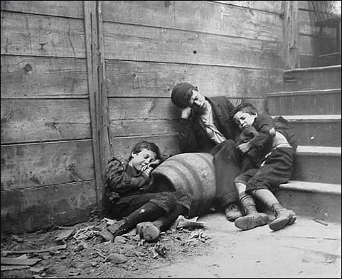

**Jacob Riis – *Street Arabs in their Sleeping Quarters***

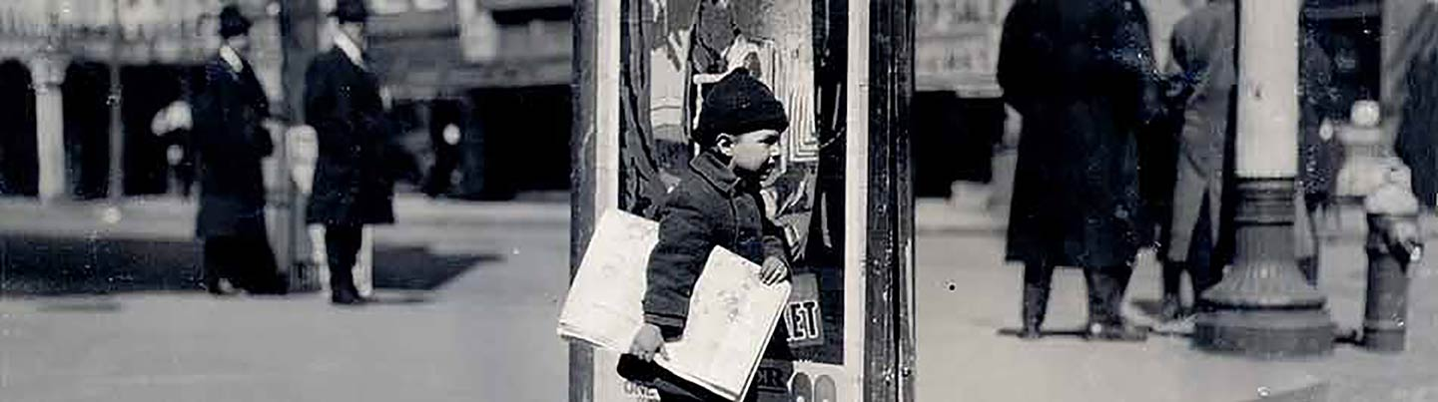

**Young Newsie**

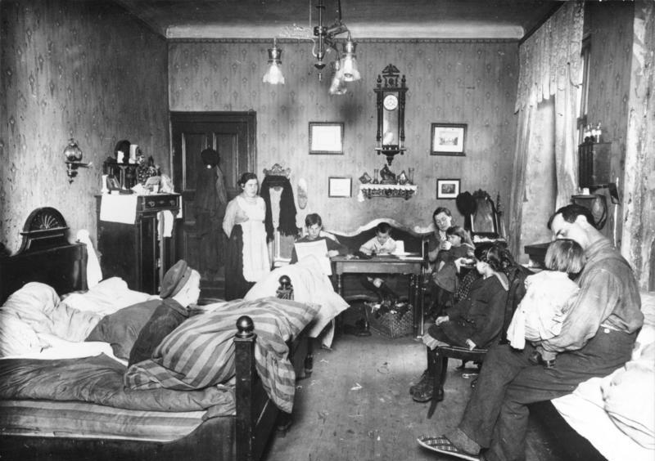

**Life in the Tenements**

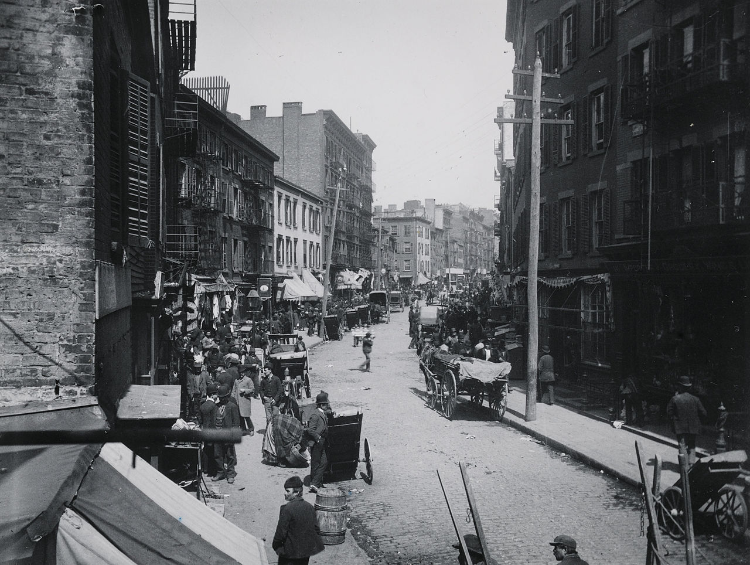

**Life in New York City**

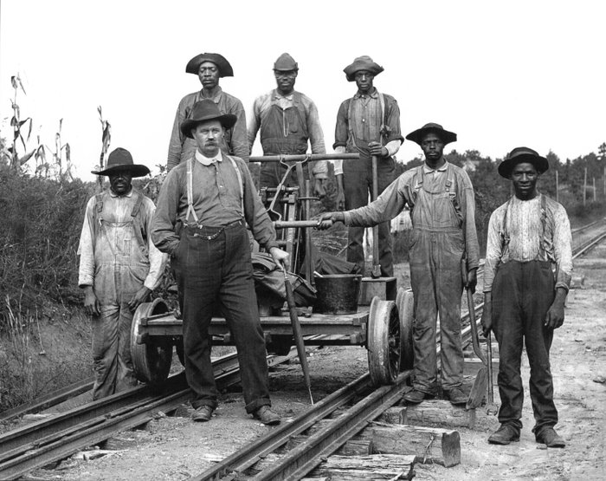

**Railroad Workers**

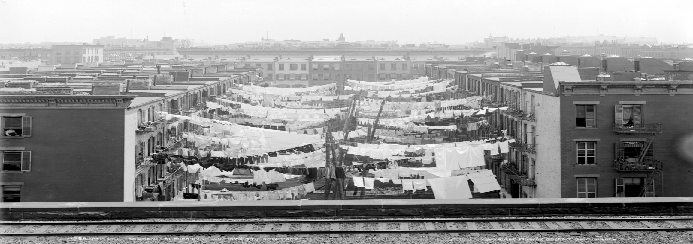

**Life in the City**

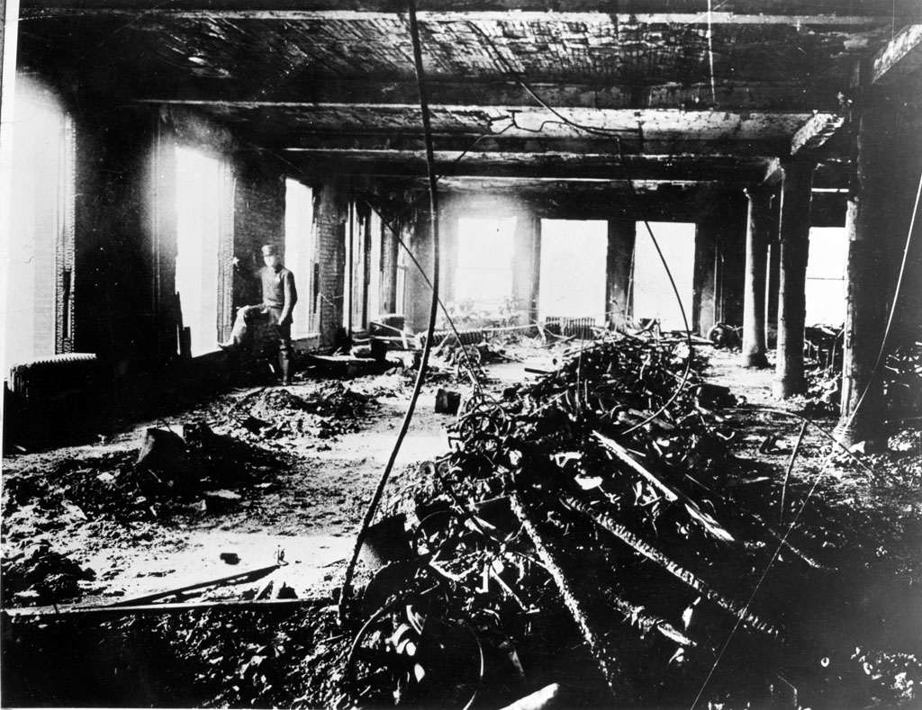

**Shirttail Waist Factory Fire**

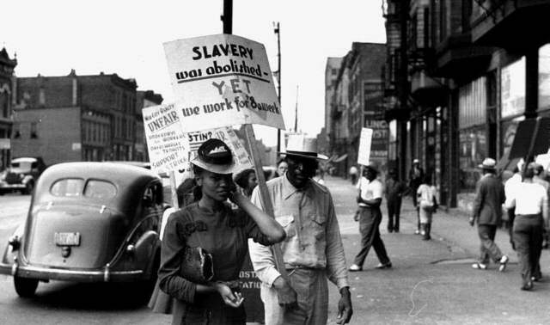

**Protests over discrimination in Chicago**

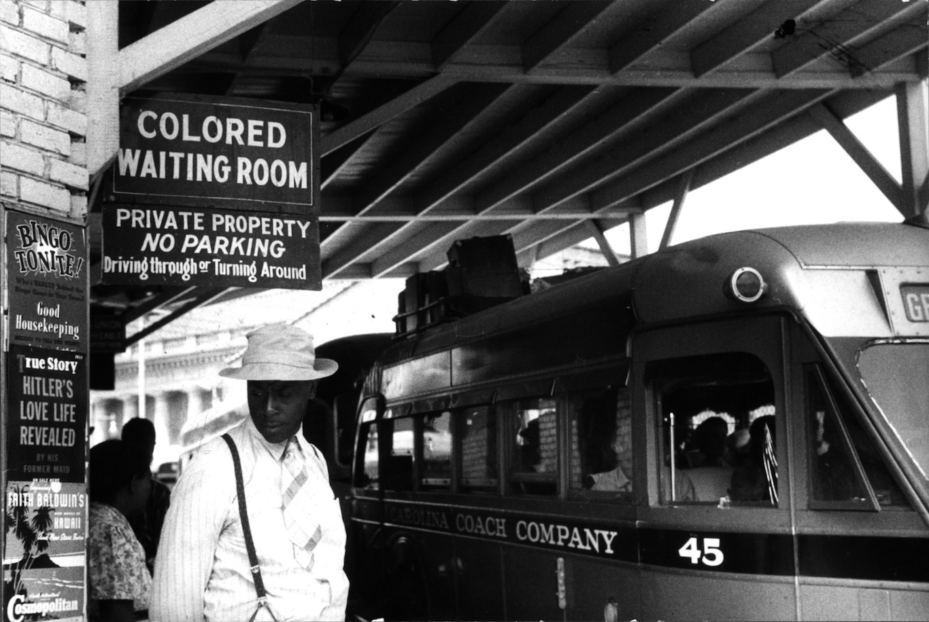

**Jim Crow Laws**

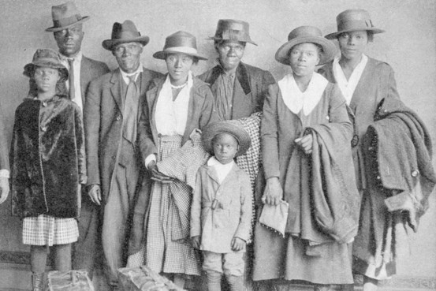  
**African American Family moving from Rural South to Chicago**

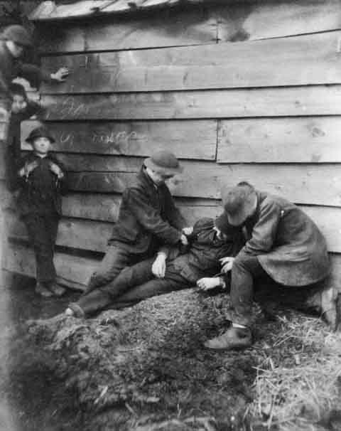

**Members of the Gang Showing How They ‘Did the Trick**

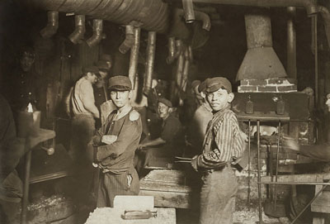

**Factory Life**

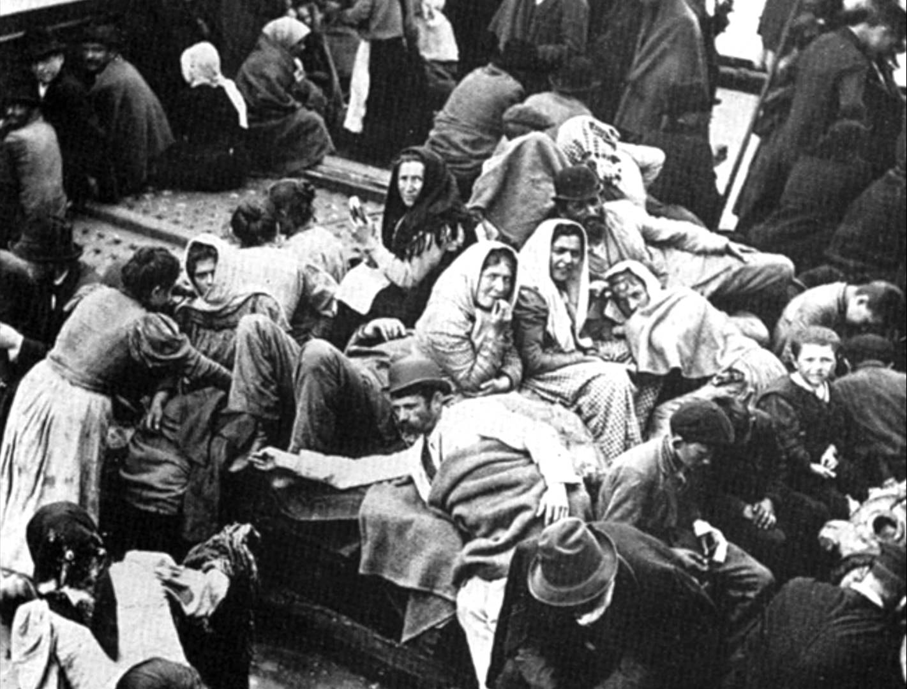

**Arriving at Ellis Island**

**Women in from the Lowell Mills** 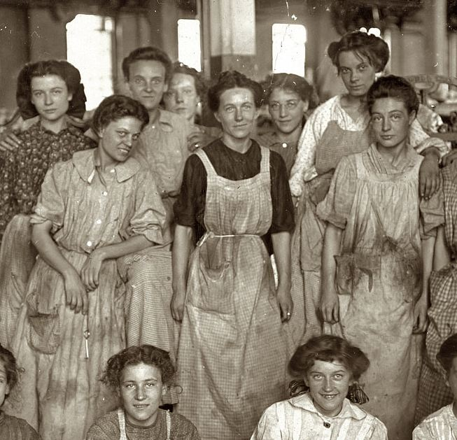

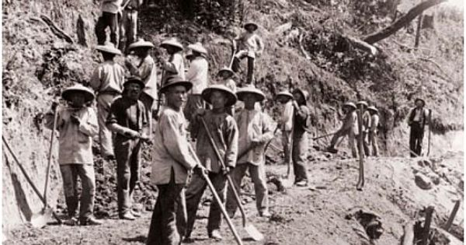

**Chinese Railroad Workers**

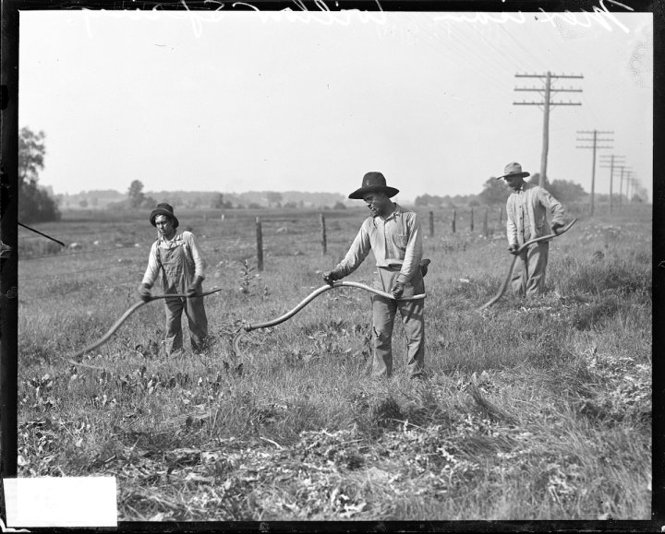

**Mexican Workers on a field outside of Chicago, 1917**